

**Uncertainty, Policy and Financial Markets**

Speech given by

Sir John Gieve, Deputy Governor, Bank of England

Market News event, Barbican Centre, London 24 July 2007

1

All speeches are available online at [www.bankofengland.co.uk/publications/Pages/speeches/default.aspx](http://www.bankofengland.co.uk/publications/Pages/speeches/default.aspx)

##### Introduction

When I took on this job last year, interest rates had moved only twice in 24 months – once up by 25bp and once back down again. Elsewhere we had seen, both in the US and the EU, two years in which rates had been on a well signalled upwards path, while interest rates in Japan remained anchored to zero. The ‘Great Stability’ seemed to have reached its zenith of total predictability.

However, one of the things that struck me from the outset in the MPC was that the predictability outside was not matched by any complacency or self certainty inside. There was a vigorous debate underway about the state of the economy and the policy response. At that stage, some members of the committee doubted that the economy and employment would recover from the slowdown in 2005 without a further reduction in rates, while others, notably David Walton, saw emerging dangers on the other side.

The economy has strengthened since then and we have had to raise interest rates 5 times in the last year. One thing that has not changed is the vigour of the internal debate. This is not (only) because economists are famously argumentative. As someone once noted, economics is the only field in which two people can get a Nobel prize for saying opposing things! Instead, the level of debate reflects genuine and unavoidable uncertainty about the economy which was disguised by the stability of rates but never went away. The fact is that we can never be sure we

have interpreted the past correctly – there are always alternative plausible interpretations– and we know the future will contain surprises.

I want to start today by discussing that range of uncertainty. I will then look at three uncertainties affecting financial markets at the moment: the losses in the US sub prime market, the significance of influential investors including sovereign wealth funds, and the state of the credit cycle.

##### The range of uncertainty

The last ten years have become known as the ‘Great Stability’. Certainly that has been true for the UK. The last quarter was the 60th of uninterrupted positive growth and it was a touch above the average for the last 10 years. On inflation too we saw this month another step back towards target and in 10 years we have only seen one month when the CPI has been more than 1 percentage point away from target **(Chart 1).**

For anyone, like me, who was in the Treasury through the late 70s and 80s, this looks like the promised land; a degree of stability we did not think was attainable. Looking back we can see that it was the pains and problems of those decades culminating in being forced out of the ERM that produced a broad political consensus on a new approach to monetary policy and the independence of the Bank. And my predecessors can take great credit for the success of recent years. We have also been benefiting from benign world conditions with the emergence of low cost producers in the Far East and strong world GDP growth, which has

been over 5 % in the last 3 years, the strongest 3-year period of growth since 1968-70, and there is every reason to hope that this benign trend will continue.

However it is important not to exaggerate this stability or to forget the substantial uncertainties that still exist. The last decade has seen some big and unanticipated changes. Since 1999, oil prices have risen from below $20 a barrel to over $70 a barrel, the US Fed funds rate has varied between 1% and 6.5%, and the stock market has experienced its post dotcom boom, bust and recovery, with the FTSE All Share falling from its 2000 high of over 3200 to below 1660 in 2003 before now recovering to over 3400. We have seen 9/11 and the onset of a new form of international terrorism, the explosive growth of new financial instruments and new players to exploit them, and we have seen the emergence of China and India into major forces in the world economy.

But uncertainties arise not just because there will always be unexpected events, changes of technology and taste. We also continually review and update our views on the underlying relationships between countries, firms and people. And of course we are constantly learning more about the past not least as the statistics get revised.

We try to emphasise those uncertainties by always publishing our forecasts in the form of fan charts which show not just a central projection but a probability distribution around it.

If you go back a year to May 2006, our central projections for Q2 2007 were for growth of about 3% and inflation of around 2%. But we also showed about a one in four chance that growth would be a percentage point or more away and that inflation would be half a percentage point from the central projections (**Chart 2**). It follows that there is also a range of uncertainty around the right path for interest rates. The story of the last year has been that growth has been stable (between 0.7 and 0.8% each quarter) and kept quite close to that central projection but only on the basis of substantially higher interest rates than our forecasts were based on; inflation has been higher than we projected again despite the successive rises in rates.

You might expect this range of uncertainty to be reflected in a range of independent forecasts, but you would be disappointed. Most forecasters operate models much like ours and, of course, they use the same data. It is perhaps not a great surprise then that their central projections tend to cluster in a remarkably narrow range. For example, take the forecasters who were surveyed by Reuters prior to the July MPC meeting last year. At that point there were only two out of 47 who expected interest rates to rise above 5% by now and only one expected them to be below 4.25%. Fast forward to the most recent survey and you will see that none of the 52 expect rates to go above 6% in the next year and only two expect rates to go below 5.5%. To gauge the real range of uncertainty you need to look beyond the central forecasts at the full probability distribution of possible outcomes. The fact that most forecasters agree on the prospect does not mean it is likely to happen.

Central banks need to be particularly cautious in putting weight on market expectations and outside forecasts because they are based at least in part on judgements about what we will do. In my view it is sensible for independent forecasters to assume that we will do our job and keep inflation low; but we can’t take comfort from the fact that most external forecasters therefore expect inflation to return and stay around target – its our job to justify their faith and keep their confidence. We must avoid chasing our own tail.

Of course, the uncertainty of the future and of the past is a factor in our decisions on interest rates. When we are feeling our way in trying to assess the pressure of demand in the economy, it can often be sensible to move rates gradually so that we can gather more information as we go on the effect of past rises. But, of course, we all know that if we get behind the curve, gradualism could compound the problems. The pace as well as the direction of any change is therefore a matter for discussion in most MPC meetings.

Looking at the economy today there are as wide a range of uncertainties as ever, for example about the level of slack in the labour market, the pricing pressures in companies, the future path of oil prices and the strength of monetary growth. I want to discuss three which arise from developments in financial markets, and which are relevant to both the Bank’s core purposes: monetary stability and financial stability.

##### Sub prime and the credit markets

Let’s start with the credit markets. The backwash from defaults in the US sub prime market has been seen not just in the recent problems faced by some hedge funds1 exposed to this sector but in credit markets more widely. Credit spreads have widened especially for riskier bonds (**Chart 3**), the covenant lite loans on offer a few weeks ago are off the table, and the leveraged loans in the warehouses are reported to be moving more slowly. And this has happened at a time when long term interest rates have been rising.

We have seen shocks to credit markets in the last two summers which were swiftly reversed. Could recent events be the beginning of a more lasting change?

There are some good reasons for doubting it. First the underlying economic and corporate fundamentals remain encouraging. Not only is world growth running at over 5% but it seems better balanced with the recovery of Germany and Japan and slightly lower growth in the US (although one of the explanations for the rise in longer term risk free rates has been a more optimistic view on US growth prospects). In the corporate sector overall gearing is not unusual, pension deficits have diminished, and profitability is high. Defaults in the prime housing market in the US have not shown dramatic increases. Losses on mortgage lending in the UK are still very low and there seems no prospect of a significant rise in unemployment that led to sharp rises in repossessions and defaults in the past.

1 In particular, the High-grade Structured Credit Enhanced Leverage Fund and the Higfh-grade Structured Credit Fund both managed by Bear Stearns Asset Management (BSAM).

Equity markets remain strong at multiples of earnings which are little above average. Again, within financial markets, liquidity remains high overall (**Chart 4**).

Against that background, there is a risk of becoming alarmed by good news. In our last *Financial Stability Report* we identified the low risk premia in credit markets as the principal vulnerability in financial markets because of the risk it carried of a swift and disorderly return to more normal levels. The rise since then has not been large in a longer context (**Chart 5**) but in itself it is a healthy correction. At the same time we have seen a fall in the dollar over recent months which should tend to reduce the risk of a sudden correction of global imbalances, another of the key vulnerabilities we have been monitoring in recent years.

But the story of the sub prime market is not yet over and it certainly does point to some vulnerabilities in modern financial markets which need to be factored into financial firms’ risk management.

First, this was a layered market in which many originators had an incentive to maximise volumes, where the loans were then securitised and the securities were in turn combined into CDOs for onward distribution.

One risk in such markets is that there is a loss of information along the chain and that incentives become misaligned; in particular the quality of credit monitoring and credit assessment declines. It is difficult to avoid the conclusion that occurred in 2006 in the sub prime markets. **Chart 6** shows the arrears on successive

tranches of loans and shows that the quality declined over time particularly in 2005 and 2006.

Second, the new derivatives markets change the way in which credit losses hit balance sheets. In the world of on–balance-sheet lending, when defaults begin to turn up, there can be scope for rescheduling and for discussing with your accountants what provisions are prudent. We saw that impact on a few of the big banks earlier this year. In the securitised markets, the pace can look slower to begin with but then comes in a rush. **Chart 7** shows the spreads on different tranches of the ABX index, the main benchmark index for sub prime securities. What is remarkable here first is how slow the spreads were to move at all. Of course, the predicted losses on particular tranches do no move smoothly with rising defaults, but throughout 2006 the economic press was a buzz with worry about the US housing market; sentiment changed several times on whether the housing downturn would lead to a general recession. Throughout this period the originators continued to write new sub prime loans and the prices of the ABX scarcely quivered.

But since January the story has been quite different with two dramatic hikes in the spreads first of BBB and then of the A-rated index. In total, the spread for BBB has gone from 500 basis points at the turn of the year to over 3000 basis points.

Each of these steps has left casualties. Many of the originators were forced into bankruptcy at the start of the year and in the last few weeks we have seen Bear Stearns’ announcement that two of its funds have lost all or nearly all of their investors’ money. I suspect the speed and scale of the changes were outside most

stress test simulations. And while the most dramatic changes may have happened there will now be a long period as the implications work through the ratings of other derivatives and the full range of instruments are marked to market.

A related lesson is about liquidity in new markets. The worry has been that at times of stress, liquidity would dry up and it would be impossible to trade out of positions. That would not just lock firms into losses but would disrupt strategies which require continuous dynamic hedging – for example, strategies such as constant proportion portfolio insurance (CPPI). Again that has been a feature of recent weeks. It has been widely reported that a couple of the lenders to the BSAM funds put their collateral on the market but were not able to sell as much as they wanted.

That is connected to the fourth lesson, the vulnerability of valuations in sophisticated derivatives. These are not widely traded so valuations are usually based not on market prices but on models which draw in turn on correlations established over the recent past. This is a fundamental and unavoidable feature of new products and markets. There simply has not been a full cycle’s experience to draw on.

When we published *our Financial Stability Report* in April we drew attention to the sub prime history as a warning of what could go wrong in bigger and more central credit markets. Developments since then underline that message. If some of the price moves in the sub prime CDOs have spread to CLOs based on

leveraged loans and buy-outs, that is hardly a surprise given recent growth in that market (**Chart 8**).

There are signs that the speed with which the pipeline of leveraged deals is being warehoused has slowed down at least temporarily and the terms of some of the lending has tightened a little. But that said there are some significant differences between the sub prime and corporate loan markets. First corporate profits remain robust and there has not been the step up in defaults that ushered in the sub prime crisis. Second while the total size of the corporate bond market dwarfs the sub prime mortgages market that is not true of the leveraged corporate loan market **(Chart 9)**.

##### The weight of money – pension funds and sovereign wealth funds

A second development in financial markets in the news at present is the growth of sovereign investors and of ’Sovereign Wealth Funds’ in particular. While these have long been established in Singapore, Norway and the Middle East, the decision of China with its huge foreign exchange reserves to diversify its investments is new. The question is what effect, if any, the growth of influential investors like these is having and may have in future on relative prices in financial markets.

Economists tend to assume that asset markets are efficient so that any deviation from fundamental value represents a profit opportunity that will be quickly eliminated through the actions of rational traders who are constantly on the

lookout for such opportunities. Underpriced assets are bought while overpriced assets are sold short, thereby bringing prices back in line with their fundamental value. In this way, investment flows and trading activity should not impact prices, unless they reflect information about the fundamentals. In practice the position can be more complicated.

In the UK, demand for long-term gilts from pension funds is widely thought to have had a significant impact especially on indexed gilt prices. Trustees have become more concerned in recent years to reduce the volatility of funds’ valuations, since changes now appear on the sponsoring companies’ balance sheets. There has been a wide move towards Liability Driven Investment (LDI) and to matching their long term liabilities either by buying more index-linked bonds or by buying equivalent hedges in the derivative markets. The narrowing of pension fund deficits as equity markets have improved may have strengthened the trend since funds may now want to ‘lock in’ the improved position. Even a relatively small shift in pension funds’ strategies would represent a large increase in demand relative to the size of the inflation-linked bond market**.** During 2005 and 2006, anecdotal evidence suggested that UK pension demand for gilts (and associated hedging by dealers) was a contributory factor in driving long-horizon sterling nominal and real interest rates lower. Indeed, this may have been one reason why UK long-term real interest rates fell by more over this period than overseas rates**.**

Assessing the impact on gilts prices is important for the Bank because we commonly use the differences between indexed and conventional gilts to estimate

longer term market inflation expectations. And these calculations have shown an increase in forward inflation breakevens especially in the last few months as nominal long term rates have increased **(Chart 10).** If that reflects a genuine increase in investors’ expectations of future inflation in the long term that would imply a loss of credibility in the UK regime.

However, there are few signs from surveys and market intelligence that UK long- run inflation expectations have picked up. Market contacts cite the sheer weight of institutional demand in the relatively illiquid index-linked gilt market as a more likely explanation why the price of long-dated index-linked gilts has not fallen by as much as conventional bonds over recent months.

The comparisons are complicated by the fact that the measure of inflation that is used to index gilts is the RPI while our target is set for the CPI and the gap, which largely reflects the impact of interest rates and house prices on the RPI is significant, is about 0.7% on average and variable (**Chart 11)**. But even making an adjustment for that, the rise in inflation breakevens is significant.

Of course, if inflation at long horizons is not generally expected to increase as the forward rates at face value might indicate, why don’t some other investors with different risk appetites sell short the overpriced index-linked bond? One answer may be that there are significant market frictions. For example, trading long- horizon forward inflation requires an investment period of many years, over which market volatility must be endured, and most speculative players have significantly shorter investment horizons. Second, transaction costs (bid-offer) are typically

higher in index-linked than conventional instruments, partly because the risks in holding inventory are not predictable and are not easily hedged.2

It may be that, against the background of more volatile realised inflation over the past year the rise in breakeven inflation rates reflects an increase in inflation risk premia, the compensation required to bear unexpected changes in future inflation. And the marginal buyers of index-linked bonds (typically insurance companies and pension funds) have become more willing to pay a premium for these assets because they better match their liabilities. Rather like entering into an insurance contract, these investors may be willing to pay a higher price for index-linked securities because the payoffs may be received in states of the world when they are most valued. Such institutional factors probably account for some part of the measured rise in forward inflation rates. Nonetheless the stability of inflation expectations will remain a key concern for the MPC.

##### Sovereign Investors

In a global context, another influential set of investors in financial markets over recent years have been holders of official foreign exchange reserves and Sovereign Wealth Funds (SWFs). A by-product of large current account surpluses, the funds available for investment have ballooned over the past few years – foreign assets held by sovereigns globally currently stand at US$7-8 trillion, of which around US$5 ½ trillion is held as international reserves. This is

2 Partly because of the strength of this institutional demand (and their tendency to buy bonds then hold them to maturity), inflation-linked markets are significantly less liquid than their nominal counterparts. DMO data show that as a proportion of the market capitalisation of bonds outstanding, turnover in the IG market is about 1/6th that of the conventional gilt market.

around 5 times higher than the level seen in the early 1990s, and could well be an understatement. The growth in foreign assets has been particularly rapid in Asian countries (especially China) and oil and gas exporting economies, including Russia **(Chart 12).**

It is difficult to be precise about the size of SWFs because they are not recorded explicitly in most official statistics. But recent estimates suggest that their foreign assets are in the range of $2 –2 ½ trillion and they are rising rapidly.

There is no consensus on the effects that this recycling of foreign exchange reserves is having on global financial markets. The market for US Treasuries is exceptionally deep and liquid, but with foreign official investors3 accounting in aggregate for around 30% of the total US Treasury debt market, some academic studies suggest that they may have kept the nominal yield on the 10-year US Treasury a hundred basis points lower than they would have been otherwise.4

The perception that official buyers may well have different aims and risk appetites to other commercial investors could give them more influence in the markets.

And, as with UK pension funds, they may genuinely alter the risk and term premia in some markets.

Within these accumulating reserves, the growth of SWFs will alter, at least at the margin, the asset mix of official balance sheets. Over time that will tend to

3 The definition of the official sector in the US Treasury survey also includes public bodies such as oil stabilisation funds.

4 See ‘International capital flows and US interest rates’, NBER working paper 12560, October 2006.

increase the price of riskier assets, like equities and corporate and emerging market bonds, compared to government bonds. The impact will be greater if there are concentrations of investment in particular asset classes or countries. More widely, the switch of reserve rich countries from lenders to owners of financial or real assets is also likely to lead to political tensions and pressures for protectionism.

##### The credit cycle and monetary policy

The knock on effects of defaults in the US sub prime market and the impact of big investors on asset prices are factors we need to assess not just in trying to understand the financial sector and the stresses it faces but in gauging the state of the economy more widely.

The story of the sub prime market illustrates a wider point. In traditional banking markets in the past there has been an observable tendency for banks to overshoot both in offering credit at the top of the cycle and retrenching afterwards. That feeds through into asset prices and can have an impact on the wider economy.

Despite the sophistication of the new capital markets, a very traditional cycle seems to have been alive and kicking in sub prime.

A similar story could be told about the credit card and other unsecured lending over the last few years. The growth rate rose in the late 90s until defaults began to build up over the last 2 years and the banks and other lenders tightened up terms and conditions sharply (**Chart 13**). The path of commercial property prices in recent years suggests the same has been happening there (**Chart 14**).

In both cases there were genuine and lasting changes in technology and the costs of supply as the development of IT improved credit scoring and allowed the distribution of securitised risk to a wider range of investors. However, there are clear signs, at least in unsecured credit for households, that the lenders overshot. It seems likely that something similar has been going on in some leveraged loan deals. The position in the biggest markets – the mortgage market and mainstream corporate lending – are less clear.

How far recent growth rates in money supply and in asset prices reflect a credit supply cycle and, if so, where we are in the cycle are questions we have been discussing on the MPC. If we could be confident of the answers there would be a strong case for using monetary policy to help stabilise growth and inflation by ‘leaning into the wind’ – that is, raising rates a little faster or further than we would otherwise have done on the upswing and reducing them quicker on the down swing. In practice the diagnosis is rarely clear cut. The sub prime losses and the impact of large investors are two factors complicating matters at the moment.

##### Conclusion

The old Chinese curse - “may he live in interesting times” – might be designed for central bankers. Our job is to keep things stable and boring. But there are limits in a rapidly changing world to what is possible. My argument is that the uncertainties today are a return to normality after two years of exceptional predictability in monetary policy both in the UK and elsewhere.

A particular area of uncertainty at present is in the credit markets. The dangers of combining a traditional credit cycle with the new derivatives markets have emerged in the US sub prime sector. The US housing market is in its downswing and there are some signs that the same is true in the UK of unsecured credit and commercial property. The position of the bigger UK sectors is less clear cut. The shift in pension fund priorities and the growth of sovereign wealth funds are further clouding the picture.

It is our job on the MPC to work through these issues and reach a judgement on them. Our target is to reduce inflation to 2% and keep it there. I can assure you that we will do whatever is needed to achieve that.

# Chart 1: Volatility of GDP and C

## Chart 2: GDP and CPI fan charts from May 2006 Inflation Report

Real GDP Growth

PI

Per cent

5

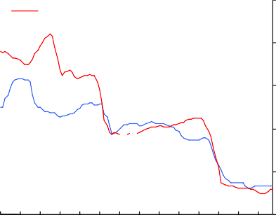

CPI

4

3

2

1

0

79 81 83 85 87 89 91 93 95 97 99 01 03 05

### Chart 3: Corporate bond spreads

Basis points Basis points

## Chart 4: Financial market liquidity

80

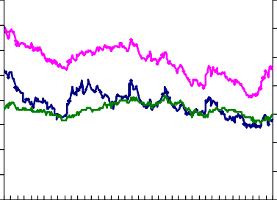

High Yield corporations (RHS)

Emerging markets (RHS)

Investment Grade corportations (LHS)

70

60

50

40

30

20

10

0

Jan

Apr Jul Oct Jan Apr

Jul

350

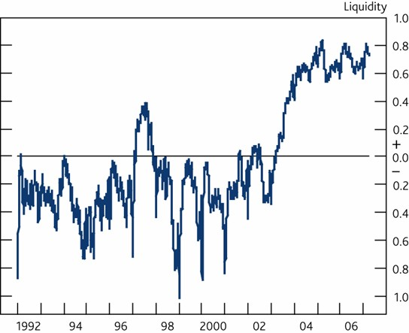300

250

200

150

100

50

0

2006 2007

#### Chart 5: Corporate bond spreads

Basis points Basis points

## Chart 6: US sub-prime arrears

**12**

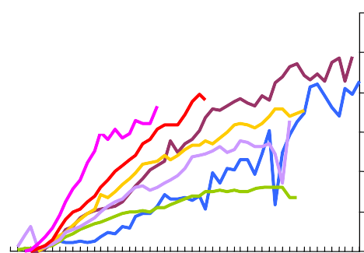

2000

2001

2002

2003

2004

2005

2006

Per cent

180

160

140

120

100

80

60

40

20

0

00 01 02 03 04 05 06 07

900

800

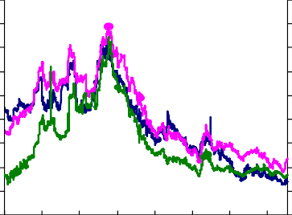

High Yield corporations (RHS)

Emerging markets (RHS)

Investment Grade corportations (LHS)

700

600

500

400

300

200

100

0

**10**

**8**

**6**

**4**

**2**

**0**

**0 5 10 15 20 25 30 35 40 45 50**

Age in months

### Chart 7: Spreads on ABX index

Basis points

3500

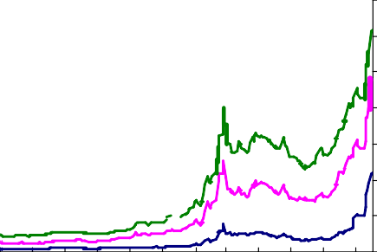

BBB-

BBB

A

3000

2500

2000

# Chart 8: Real LBO loan issuance

Aug Sep Oct Nov Dec Jan Feb Mar Apr May Jun Jul 2006 07

1500

1000

United Kingdom US$ billions, 2006 prices United States **300**

Rest of Western Europe

Rest of world **250**

**200**

**150**

**100**

**50**

**0**

**86 88 90 92 94 96 98 00 02 04 06(b)**

United Kingdom

United States **300**

**250**

**200**

**150**

**100**

**50**

**0**

**86 88 90 92 94 96 98 00 02 04 06**

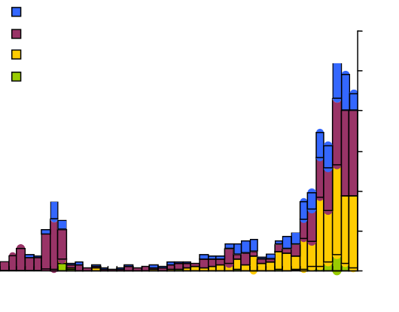

United Kingdom United States

Rest of Western Europe

Rest of world

US$ billions, 2006 prices

**300**

**250**

**200**

**150**

**100**

**50**

**0**

**86 88 90 92 94 96 98 00 02 04**

**06(b)**

500

0

### Chart 9: Corporate bond, leveraged loans and sub-prime markets

$bn

Chart 10: Breakeven inflation forward rates

US and European leveraged loan markets US sub-prime

European sub investment-grade bond

US sub investment-grade bond European investment-grade bond US investment-grade bond

2002 2003 2004 2005 2006

12000

10000

8000

6000

4000

2000

0

May-06 Jul-06 Oct-06 Jan-07 Apr-07

%

4

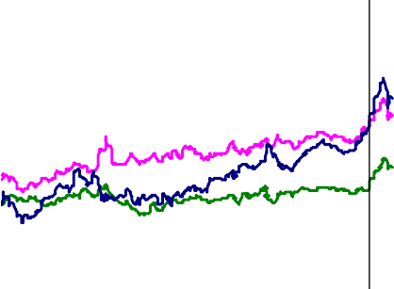

June MPC

20 year

10 year

5 year

3.75

3.5

3.25

3

2.75

2.5

#### Chart 11: Inflation gaps

Chart 12: Official exchange reserves

Percentage changes on a year earlier

Other (Indonesia, Malaysia, Philippines, T hailandU) S$ bn India

Singapore Hong Kong Korea

Taiwan

Japan China

OPEC, Rus, Kaz

3500

3000

2500

2000

1500

1000

500

2.5

RPI-CPI

RPIX-CPI

2.0

1.5

1.0

0.5

0.0

00 01 02 03 04 05 06 07

-0.5

Dec- 00

Dec- 01

Dec- 02

Dec- 03

Dec- 04

Dec- 05

Dec- 06

Mar- 07

Chart 13: Lending to individuals

**% change oya**

**20**

**Unsecured (16%)**

**Total**

**18**

**16**

**14**

**12**

**10**

**8**

**6**

**4**

**2**

Chart 14: Commercial property capital values growth

**1994 1996 1998 2000 2002 2004 2006**

Percentage change on **30**

previous year **25**

**20**

**15**

**10**

**5 +**

**0**

**5 -**

**10**

**15**

**20**

**80 83 86 89 92 95 98 01 04 07**

Percentage change on

previous year

**30**

**25**

**20**

**15**

**10**

**5 +**

**0**

**5 -**

**10**

**15**

**20**

**80 83 86 89 92 95 98 01 04 07**